Jordan Heaton
Brief Overview
The routine I picked for this project is my morning routine. After moving to my new place for London, I noticed my old process was inefficient, so I started tracking a fixed routine starting Sunday, June 7. Each day starts as soon as I wake up: shower, shave, get dressed, eat breakfast, and brush my teeth. That sequence is the baseline I'm using to measure time and test improvements.
Flowchart
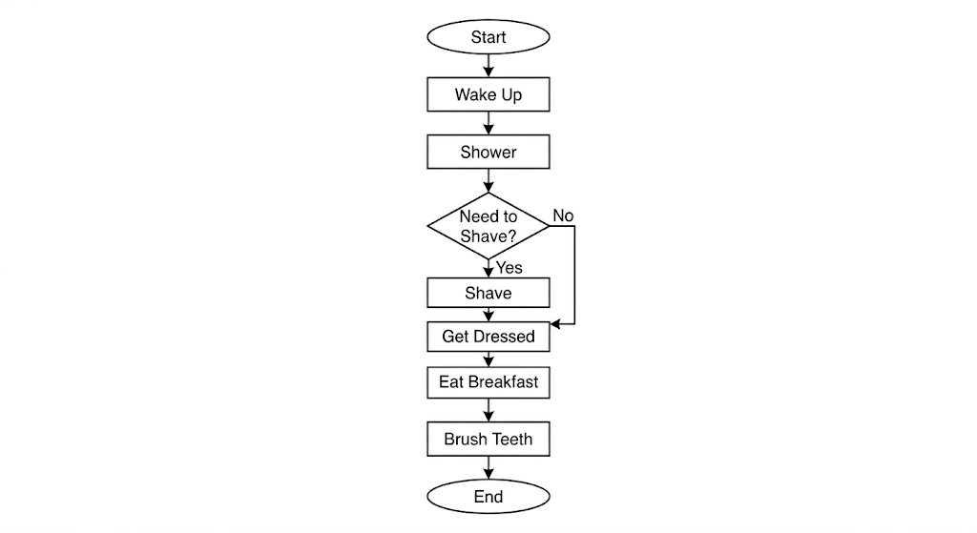
Two Suggestions
My first suggestion targets the time I spend showering and shaving, since together they take up the biggest chunk of my morning. To cut that down without rushing, I'm using a timer: 10 minutes for the shower and 5 minutes for the shave, so 15 minutes total in the bathroom. A clear time limit keeps me from lingering but still leaves enough room to do both tasks properly. Tightening up this part of the routine should free up a few minutes I can put toward the rest of the morning.
The second suggestion moves prep for the "Get Dressed" and "Eat Breakfast" steps to the night before. Each evening, I lay out my clothes for the next day and put together a grab-and-go breakfast, like overnight oats or a premade smoothie, so it's ready the moment I want it. That cuts out the time I'd otherwise spend deciding what to wear and preparing or cleaning up breakfast during the morning rush. Moving those decisions to the evening, when I have more time and energy, should make my mornings faster and less stressful.
Times Table
Trial # | Original Process Time (Minutes) | Improved Process Time (Minutes)
1 | 42 | 32
2 | 37 | 28
3 | 40 | 29
4 | 50 | 28
5 | 49 | 30
Average | 43.6 | 29.4
Line Graph
Analysis
Both changes improved my morning routine, and not just in terms of speed. I didn't expect laying out my clothes and prepping breakfast the night before to help as much as it did. Deciding on an outfit and food in the evening, instead of scrambling for both during the rush, cut down on the mental clutter and lowered my stress. The shower and shave timers worked the same way: they kept me from lingering in the bathroom. Even on the one trial where I forgot to set the timer, the routine still felt smoother and more consistent than before. Importantly, the timers never lowered the quality of the routine itself—my showers were still thorough and my shaves complete—so I saved time without cutting corners. Overall, my prep time felt less rushed and more organized.
In terms of time saved, the results were clear. The original process averaged 43.6 minutes across five trials, while the improved process averaged 29.4 minutes, a savings of about 14 minutes a morning. The original process was also less predictable: the longest trials hit 50 and 49 minutes, while the improved trials stayed in a tight range between 28 and 32 minutes. Those longer mornings usually came from a slow start or getting distracted, which the structure of the improved routine helped eliminate. Every trial using the improved process beat every trial of the original. That consistency shows both changes had a real effect on efficiency. Shifting clothes and breakfast decisions to the night before in particular removed the slowest and most variable steps of my morning.
Reflection
This project showed me that I can make real improvements in my personal life just by taking time to reflect and act on it. Process improvements don't have to be only about speed; they can also make a daily routine feel calmer and more organized. Laying out my clothes the night before and setting a timer in the bathroom are small changes, but they had a real effect. I came away from this realizing I can spot problems in my own routines and actually fix them, which makes my mornings more peaceful.
This project also gave me more confidence in my ability to analyze and improve a process for my future career. Being able to lay out an improvement idea and back it up with tracked results matters in any organization, since it saves time and increases efficiency. Those skills come up constantly in operations and supply chain roles. Making changes based on real data will help me work more efficiently myself and help my coworkers do the same. This project left me thinking of continuous improvement as something I want to keep applying, both at work and at home.

